One locus

We suppose that all of those who died were homozygous for an allele M that would make them susceptible to death from measles. Since we know how many people were born during the period between outbreaks. We then estimate the frequency of those who were born assuming that there was no preference between the matching of couples with the genotypes.
In the second outbreak we assume all of those alive for the first outbreak are recovered. We again assume that all who have died are of genotype MM but that not all of those with that genotype contracted the disease. When we make the assumption that all of those susceptible but not of genotype MM contracted the disease we get a reproductive ratio of approximately 2.
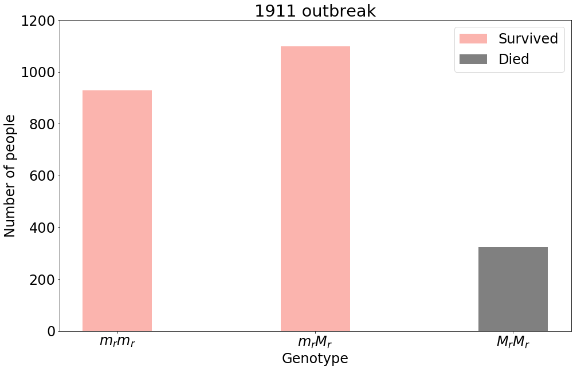

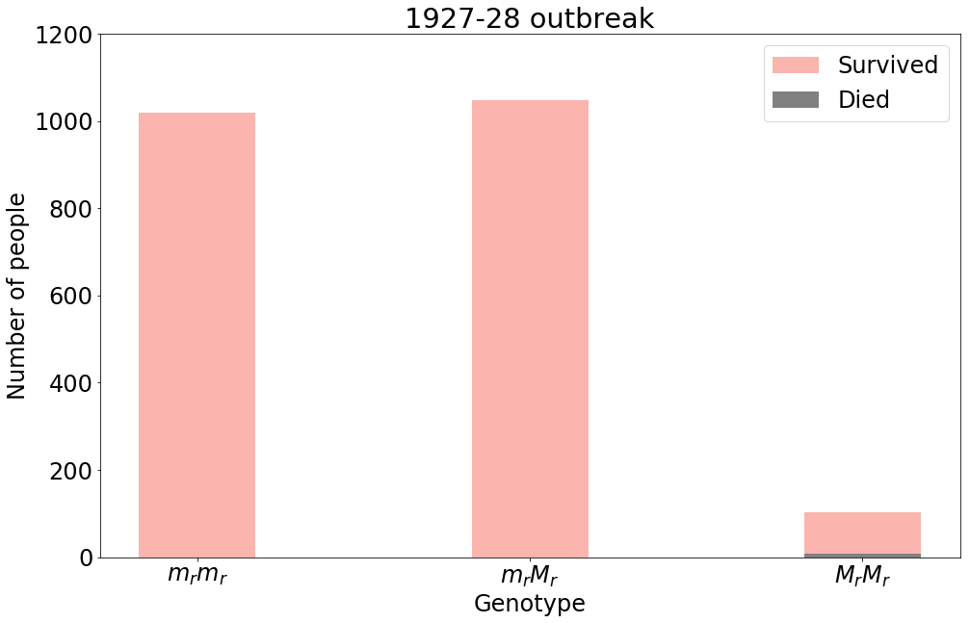

Two Loci
If we instead suppose that those who died were homozygous for 2 alleles. Then the frequency of both of those alleles squared and multiplied together would have to be around 0.13h. Allowing these alleles to be of equal frequency would mean that they would have frequency of approximately 0.6 each therefore both alleles would be the most frequent in the population.

Most of those in the tail of the epidemic also have pthisis listed on cause of death.

